FIXTURES 2023

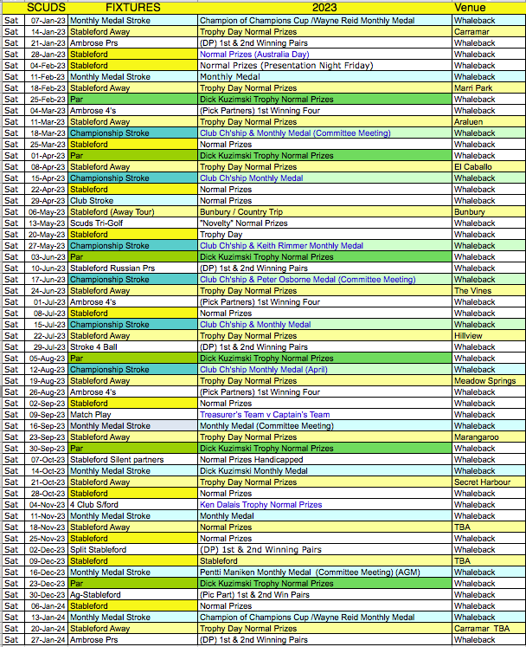

Handbook 2023
dbook 2023

Affiliated to Golf WA
Phone: (08) 9367 2490 | admin@golfwa.org.au | Fax: (08) 9368 2255 |
Level 1, Unit 5, No 49 Melville Parade, South Perth, WA 6151

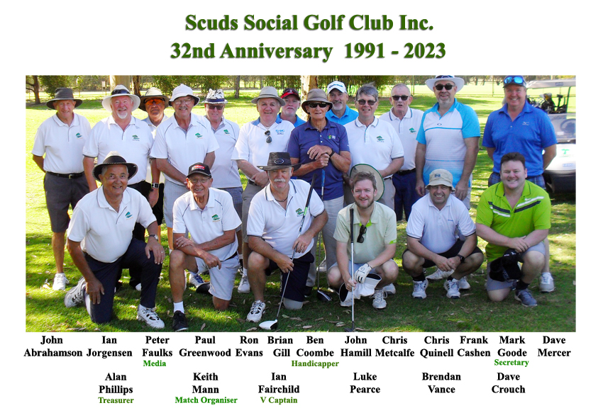

Includes new Rules 2023
Club By-Laws
and Club Constitution

Match Organiser Keith Mann 0414 751 850
Vice Captain Ian Fairchild 0427 778 019
Secretary Mark Goode 0407 761 694
Treasurer Alan Phillips 0468 318 052
Handicapper Ben Coombe 0438 984 273
Media & Communication Peter Faulks 0416 187 937
Email: scudsgolf@westnet.com.au
Web page: http://www.scudsgolfclub.net/index.html

Committee for full lists see web site honours
Year | President | Secretary | Handicapper | Treasurer | Captain | Vice Captain | Media & Communication
2013 | Mike Dobson | Steve Mann | Peter Faulks | Alan Phillips | Ian Fairchild | Keith Mann
2014 | Mike Dobson | Steve Mann | Rob Waterer | Alan Phillips | Ian Fairchild | Keith Mann
2015 | Gary Smith | Steve Mann | Mark Ensor | Alan Phillips | Ian Fairchild | Keith Mann
2016 | Gary Smith | Steve Mann | Mark Ensor | Alan Phillips | Ian Fairchild | Keith Mann
2017 | -- | Steve Mann | Peter Faulks | Lee Adam | John Abrahamson | Ian Fairchild | Peter Faulks
2018 | - | Steve Mann | Peter Faulks | Lee Adam | John Abrahamson | Ian Fairchild | Peter Faulks
2019 | - | Alan Phillips | Peter Faulks | Lee Adam | John Abrahamson | Ian Fairchild | Peter Faulks
2020 | - | Peter Faulks | Ben Coombe | Alan Phillips | John Abrahamson | Ian Fairchild | Peter Faulks
2021 | - | Mark Goode | Ben Coombe | Alan Phillips | Andy Smith | Ian Fairchild | Peter Faulks
2022 | - | Mark Goode | Ben Coombe | Alan Phillips | Andy Smith | Ian Fairchild | Peter Faulks
2023 | - | Mark Goode | Ben Coombe | Alan Phillips | Keith Mann | Ian Fairchild | Peter Faulks

Club Awards & Trophy Winners
Year | Life Members | Golden Balls Best Improved | Club Member | Richard Kuzimski Par Trophy | Hole in One | South West Tour Winner
2013 |  | Alan Phillips | Paddy Dobson | Playing a Par round |  | Jason Burgess
2014 |  | Pentti Makinen | Ian Fairchild | Scored a gross 65 | Mark Ensor (18th) | Gary Smith
2015 |  | Lee Adam | Ian Fairchild | A club Course Record | Nathan Gear | Paul Greenwood
2016 | Ian Fairchild | Jason Burgess | Lee Adam |  | Jason Burgess | Chris Metcalfe
2017 | Alan Phillips | Shannon Setzinger | Lee Adam | Shannon Setzinger | - | Ben Coombe
2018 | Barry Griffiths | John Abrahamson | Peter Faulks | Ian Fairchild | Alan Phillips (8th) | Adam Kuzimski
2019 | - | Paul Greenwood | John Abrahamson | John Abrahamson | - | Ian Fairchild
2020 | - | John Abrahamson | Peter Faulks | Frank Cashen | - | Frank Cashen
2021 |  | John Hamill | John Abrahamson &  Alan Phillips | Pat Nagle &  Russel Woods | John Hamill (Marri Park) | Frank Cashen
2022 |  | Brendan Vance |  | Keith Mann | Paul Greenwood (Armadale) | No Tour
2023

Club Champions
Year | Champion of Champions | A Grade Club Champion | B Grade Club Champion | C Grade Club Champion | Club Champion  No longer used
2013 | Steve Mann | Dick Kuzimski | Paul Greenwood | Alan Phillips | Keith Mann
2014 | John Abrahamson | Nick Williams | Keith Mann | Barry Gtirthifs
2015 | Keith Mann | Lee Adam | Alan Phillips | Ron Evans | Course Records
2016 | Peter Faulks | Stewart Smith | Mark Ensor | Alan Phillips | Putts Front 9 putts
2017 | Stewart Smith | Dwayne Davey | Mark Ensor | John Abrahamson | 11 Alan Phillips
2018 | Lee Adam | Lee Adam | John Abrahamson | Ron Evans | Putts Back 9
2019 | Chris Metcalfe | Vic Worobec | Nathan Gear | Alan Phillips | 10 Ian Jorgensen
2020 | Luke Pearce | Luke Pearce | John Abrahamson | Alan Phillips
2021 | Chris Metcalfe | Luke Pearce | Alan Phillips | Mark Goode
2022 | Stephen Hille | Luke Pearce | Pat Nagle | John Hamill
2023

Eclectic & Trophy Winners
Year | Eclectic A  Grade | Eclectic B  Grade | Eclectic C  Grade | 4 Club Ken Dalais Trophy | Touring Pro
2013 | Michael Tappenden |  |  | Mike Tappenden | Dick Kuzimski / Nick Williams
2014 | Jason Burgess |  |  | Mark Ensor | Mark Ensor
2015 | Kevin McCormack |  |  | Dick Kuzimski | P Greenwood / L Adam
2016 | Jason Burgess |  |  | Jason Burgess | Peter Faulks
2017 | Jason Burgess | Alan Phillips | Ben Coombe | Jason Burgess | Adam Kuzimski
2018 | Lee Adam | John Abrahamson | Paul Greenwood | Daniel Thomson | Shannon Setzinger
2019 | Vic Worobec | Chris Metcalfe | Paul Greenwood | John Abrahamson | Paul Greenwood
2020 | Luke Pearce | Frank Cashen | Tim Maher | Chris Quinell | Frank Cashen
2021 | Luke Pearce |  | Mark Goode | Not Played | Keith Mann
2022 | Luke Pearce | Pat Nagle | John Hamill | Brendan Vance | Chris Metcalfe

SCUDS Handbook 2023 Page 11

By Laws
1. Membership Fees (Annual)
1.1 Membership Fee… Full Member $100.00 (Includes GolfWA, Golf Link, Eclectic, Daily Raffle and Hole-In-One fees)
Scuds Social Golf Club will only accept nominations for membership from members of the public who have at least one COVID VIRUS inoculation. Members pay the full amount in February, new members after 30 June may only pay the fee for the remaining months ($10 per month) but will not be included in some trophy or eclectic competitions.
Note: Life members will pay half the Membership Fee set for that year

1.2 Membership Fee… Casual Member $25.00
(Must have a Golf Link Card, and is eligible to play by invitation or request)

1.3 Prize Breakdown
Competition Fee & Novelties: Set by the Treasurer per Competition Day
There may be up to six (6) novelties for each competition day
(competition & novelty prizes will be determined by the treasurer, dependent upon the numbers attending)
(Maximum $10 per novelty)

1.4 Individual Competition/Monthly Medal/Trophy Days.
Maximum
1st……………………………………. ⁴/₇ of Prize Pool $50 2nd…………………………………… ²/₇ $25
3rd… dependent upon the numbers attending … ¹/₇ $13

1.5 Team Competitions
Winning team (foursomes) The Pool
Winning teams (pairs) 1st… ²/3 of Prize Pool
2nd… ¹/3 of Prize Pool
1.6 Matchplay
$4.00 per person round (payable to the winner, or winning team)

1.7 Hole-in-One Competition
A Hole-in-One achieved by a Club member at any Club fixture or official GolfWA event will be awarded the prize of $200. The club will replace the prize pool, if there is more than one winner each season.

Note: Any monies remaining after competition day prizes have been awarded will be incorporated as general revenue and will be used to provide trophies and fund the end of season dinner & presentation night.

2. Competitions
2.1 Club Championships
To be played on Monthly Medal days, over five rounds,
March, April, May, June and July. Best three net score cards to count.

Champion will be declared for
A Grade Club Champion
B Grade Club Champion
C Grade Club Champion

SCUDS Handbook 2023 Page 2

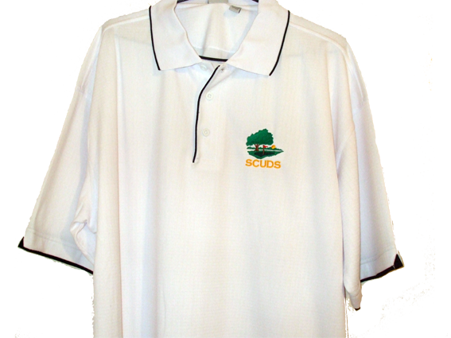

Principal Changes Introduced in the 2023 Rules of Golf
Rule 1.3c(4) Applying Penalties to Multiple Breaches of the Rules
The Rule has been amended so that determining whether breaches are related or unrelated is no longer part of its application, meaning that there will be fewer instances where multiple penalties will be applied.
Rule 3.3b(4) Player Not Responsible for Showing Handicap on Scorecard or Adding Up Scores
The Rule has been amended so that a player is no longer required to show their handicap on their scorecard. The Committee is responsible for calculating the player’s handicap strokes for the competition and using that to calculate the player’s net score.
Rule 4.1a(2) Use, Repair or Replacement of Club Damaged During Round The Rule has been amended to allow a player to replace a damaged club, provided the club has not been damaged through abuse.
Rule 6.3b(3) Substitution of Another Ball While Playing a Hole The penalty for playing an incorrectly substituted ball has been reduced from the general penalty to one penalty stroke.
Rule 9.3 Ball Moved by Natural Forces New Exception 2 provides that a ball must be replaced if it moves to another area of the course after being dropped, placed or replaced. This also applies if the ball comes to rest out of bounds.
Rule 10.2b Other Help Rule 10.2b has been amended to provide that neither the caddie nor any other person is allowed to set an object down to help the player with the line of play or other directional information (such as when the player cannot see the Flag stick), and the player cannot avoid penalty by having the object removed before the stroke is made.
Rule 11.1b(2) has been amended Principal Changes Rule 11.1b Ball in Motion If the ball accidentally hits person or an outside Influence: The place from Where Ball Must Be Played Rule 11.1b has been rewritten for clarity. Rule 11.1b(2) has been amended to provide that if a ball played from the putting green hits an insect, the player or the club used to make the stroke, the ball is played as it lies – the stroke is not replayed.
Rule 21.1c Penalties in Stableford
The Rule is amended to provide that penalties in relation to clubs, time of starting and unreasonable delay will now be applied to the hole in the same way as regular stroke play. The same amendment is made to Rule 21.3c (Penalties in Par/Bogey).
Rule 25 Modifications for Players with Disabilities
The introduction of new Rule 25 means that the modifications provided in the Rule apply to all competitions, including all forms of play.
General Changes
Back-on-the-Line Relief Procedure The back-on-the-line relief procedure is amended to provide that the player is required to drop on the line. The spot on the line where the ball first touches the ground when dropped creates a relief area that is one club-length in any direction from that point. This amendment is redirected in changes to Rules 14.3b(3), 16.1c(2), 17.1d(2), 19.2b and 19.3, and the definition of relief area.
How to Proceed When Stroke Must Be Replayed
Several Rules that used the phrase “stroke does not count” (such as Rule 11.1b) have been amended so that the failure to replay a stroke when required to do so, while still a breach of the relevant Rule, no longer carries the potential for disqualification

SCUDS Handbook 2023 Page 10

2.2 Monthly Medal - Stroke (each month January to December – may include Club Championship)
Stroke play – 12 winners, each to receive a medal or special day prize.

Monthly Memorial Medal Trophy Days

January Monthly Memorial Medal | May Monthly Memorial Medal
Wayne Reid (3/1/2010) Medal | Keith Rimmer (31/5/2006) Medal
June Monthly Memorial Medal | October Monthly Memorial Medal
Peter Osborne (30/6/2009) Medal | Richard Kuzimski (4/10/2016) Medal
December Monthly Memorial Medal
Pentti Makinen (29/12/2015) Medal

2.3 Champion of Champion's Cup.
Played on the January Monthly Medal Stroke day - Normal Monthly Medal rules apply.
The previous 12 Monthly Medal winners (January – December) are the only players entitled to compete for the Champion of Champion's Cup (plus the previous years Champion of Champion's Cup winner who is entitled to defend the cup). (Possibly 13 players).
The Champion of Champion's Cup winner will have the best score of all 13 eligible players.

The Monthly Medal for January is played in conjunction with the Champion of Champion's Cup and is open to all members playing on that day so any member can win the January Monthly Medal. A Prize will be awarded for the Monthly Medal Winner and for the Champion of Champion's Cup Winner.

The winner of the January Monthly Medal will be eligible to play in the next Champion of Champion's Cup.

2.4. Away Games (Touring Pro Award)
At least Nine (9) away games are scheduled each season, to be played as individual Stableford; winners play for normal prizes, unless a specific trophy has been nominated.
Touring Pro Award
The best-performed player (best averaged four (4) rounds) in the away games, will receive a gift. Has been donated in the past.

2.5 Four Club Stableford (Ken Dalais Trophy)
Use four clubs only

2.6 Par Champion (Richard Kuzimski Par Record Trophy)
The best-performed player (best averaged three (3) Par rounds), will receive The Richard Kuzimski Memorial Trophy. Richard Kuzimski (5 handicap) scored a magnificent plus 11 Par round on the 15th August 2015 with a Gross Stroke Score of 65 a club record.

2.7 Eclectic
Is included on all regular club rounds (excluding away games, novelty and some combination rounds). Played during January 1st to December 31st, Minimum 30 rounds.
Prizes are awarded in grade order based on the member’s final Eclectic score divided by the member’s average handicap for that season (Lowest to Highest). Three grade winners are available: A Grade, B Grade and C Grade. (Players moving i.e. from C Grade to B Grade etc. will play in the grade level as at December 31st of each year).

SCUDS Handbook 2023 Page 3

2.8 Golden Balls
The best-performed (improved) player based on the difference in handicap for the year.
Note: Not open to new members joining after April 1st that year, because the initial handicap will require an adjustment after eight (8) games played or because of Golf Link handicap adjustments that require twenty (20) games applied to determine a correct handicap. To qualify you must play 30 or more games.

2.9 Club Member of The Year (Ian Fairchild Trophy)
Nominated by the Members votes, the trophy is presented to the club member whom has made outstanding contribution to the club or social club during the year.

2.10 Life Member
Nominated by the Members, Life Members pay 50% of the scheduled membership fees, and have full member rights.

3. Tours
3.1 Country Trip
Played usually Stableford for the Saturday round (handicapped for Golf Link) and Sunday to be arranged by the Captain. (handicap to stay the same for the two rounds)
Note: This event is to be financed by the players and all prizes and associated costs will not be funded by the club.
3.2 International / Interstate Tour
Played as arranged over participating days. (not handicapped for Golf Link).
Note: This event is to be financed and organised by the players and all travel, insurance and accommodation expenses, prizes and associated costs will not be funded by the club.
3.3 Casual or Requested Tours
Played as arranged over participating days. (not handicapped for Golf Link).
Note: This event is to be financed and organised by the players and all travel, insurance and accommodation expenses, prizes and associated costs will not be funded by the club.

4 Handicap
4.1 Handicap – Golf Link
To obtain a Scuds Golf Link handicap you must submit three 18 hole stroke cards at Whaleback Golf Course, which must be marked and signed by a SCUDS member.
Note: An official Australian (Golf Australia) handicap can only be issued by golf clubs that are affiliated with a State Association that is a member of Golf Australia, which in Western Australia is Golf WA. The Scuds Social Golf Club Inc. is a member of Golf WA.
Once you have forwarded your three (3) cards to our handicapper, the committee and handicapper will then meet to determine your handicap and you will be allocated your official Scuds Golf Link handicap and issued with a Scuds Golf Link Card.

If you already have a Golf Link Card that handicap will be used once you join SCUDS and pay the appropriate fees due, and a new SCUDS Golf Link card will be issued.

4.2 Novelties
When playing in team events, each player is entitled to play for the novelties regardless of who’s ball has been selected to play.
For Example; Player “A” has used only 3 drives and needs one more at the 18th hole. Player “B” is entitled to play a shot to attempt to get nearest the pin.

SCUDS Handbook 2023 Page 4

Stroke Maximum Score
Players whom cannot finish a hole, i.e. for a lost ball/s or ball lost in the rough or too many shots in a bunker can declare a maximum score for that hole and keep playing in the round, the maximum scores are Par 3=7, Par 4=8 and Par 5=9. You must declare that you are entering a maximum score for that hole and enter the appropriate score, three putts are counted.Maximum Handicap allowed 36
Stroke Match play
Match play is a hole-by-hole contest; based on your handicap for that hole, think of it as 18 one-hole contests. The winner is the player who wins the most holes. When a player is more holes up than there are holes remaining to play, he wins. This means that matches can end before the 18th hole or they can go beyond 18 until a winner is decided. Match play even allows for ties. In those cases, a halved match results in each team being awarded a half point.

7. Club Members Badge
7.1 Club Members Badge
All members will be issued with a members bag tag which should be displayed on the golf bag.

8. Club Shirt
8.1 Club Shirt All Games,
The White Club shirt is to be worn for all games, players are required to purchase the official white club shirt upon successful application for membership. Shirts are substantially discounted for members and include the club logo.
8.2 Home Games,
For home club games white shirts or the international tour shirts may be worn.

9. General (To be read in conjunction with local course rules)
9.1 Preferred Lie, on the fairway, shall be taken in accordance with the course rules, for Scuds, this is a club length, no nearer the hole.

9.2 Bunkers Shall be played as the ball lies, although you can move loose impediments and if the bunker is damaged, or the ball is in a shoe imprint, animal scratching or water, after agreement with your marker, it may be smoothed and placed, no nearer the hole.

9.3 Slow Play The lowest handicapper in each group shall ensure that the group maintains its place in the field behind the group in front. Slow groups or groups searching for lost ball (min 3 minutes) should immediately call the other group through.

9.4 Honour Players should play when ready at the next tee off, the group should maintain its place in the field irrespective of whose honour to play.

9.5 Combined games Players paired in combined games, where a player does not have a partner, the lowest handicap player in that group will combine with each player to form two groups of pairs, make up a group of three etc. In Ambrose competition an adjustment to handicaps may be used.

9.6 Dress Code Players should comply to the dress code standard at each course played.

9.7 Blue Tees At Whaleback members will play off blue tees, members over 64 with a handicap over 20 may play off white tees if they wish, ladies may play off red tees. For away games member will play off white visitors tees, unless advised otherwise.

SCUDS Handbook 2023 Page 9

Par (Bogey) competition challenges players to beat their own handicap par. If players better their par, they score a ‘+’ (plus) for the hole. If players equal their own par, they are said to have halved or squared the hole which is scored with an ‘O’. If par is not achieved, a ‘-‘ (minus) sign is recorded. At the end of the round the plus and minus signs are added and the net result written in as plus, minus or ‘all square’. Player with the highest plus score is the winner.

Ambrose Competition (prefered lie rule change)
This event can be played as a two, three or four-person event. Each player plays a tee shot at each hole. The Captain then selects the best drive, which is then marked by its owner. The other members retrieve their balls and in turn place their ball on the fairway (one club length no nearer the hole, or if in the rough, drop in the rough within one club-length of the selected position (no nearer the hole) and play their second shots. If in a bunker smooth and place. This procedure of selecting the best position continues until a ball is holed. When on the green, balls are placed on the selected marked spot.

This event can be played as a gross event, the Club Captain will determine the number of drives per team, with each group having a spread of handicaps, or as a handicap event where a fraction of the aggregate handicaps is used. The most common method of determining handicap is:
Two-person event – ¼ of aggregate stroke handicap;
Three-person event – ¹/₆ of aggregate handicap;
Four-person event – ⅛ of stroke handicap.

4 Ball Stroke (2 Players)
Both players play their own ball throughout; For example, Players A and B form one team, at the end of each hole, the low score between the two partners on each team is that team's score.
Where single players are entered (see rule 9.5)
i.e. two players: player A on an 18 handicap and player B on a 9 handicap. At each hole the player’s handicap for that hole is calculated, the player with the lowest score records the result.

SCUD’S TRI-GOLF Each player plays 18 holes
6 holes of Stroke
6 holes of Stableford
6 holes of Par
Each player must nominate the game that he wishes to play prior to teeing off on the 1st, 7th and 13th tees
Example of scoring system
Player Name
Stroke Score 30-
Deduct 1/3 handicap 6 (18 handicap)
24
Deduct Stableford score 12-
12 pts scored
Add a ” –“ Par score or
Subtract “+”Par score +1
11 TOTAL
(The Lowest score is the winner)
Stroke
Players record the number of strokes taken at each hole and total them up at the end of a given round, or rounds. The player with the lowest total is the winner. In handicap competitions, the player would subtract their handicap from the total (gross) score to generate their net score, and the player with the lowest net score is the winner. Players need to record the Stableford score for handicap purposes.

SCUDS Handbook 2023 Page 8

5. Game Booking Procedures
To play a round of golf with The Scuds Social Golf Club Inc. the following procedures apply
Pay the green fees as per booking procedures to the Match Organiser, Vice Captain, Treasurer or his delegate, or:
* Ring and apply to the Match Organiser.
Failure to observe the above procedures may result in not being able to play on the day.
* All home games are arranged by the Handicapper (fixtures) & Match Organiser (match day).
* All away games are arranged by the Handicapper (fixtures) & Match Organiser (match day).
* Special games are arranged by the Match Organiser.

6. Golf Competitions
Stableford involves scoring points based on results at each hole. Using the index for each hole, players are able to make a mental allocation of their full handicap for each of the 18 holes.
For example, a player on a handicap of 18 will add one shot to the par value of each hole to determine their own par for the hole. The points scoring method is then calculated by allocating two points for a par, one point for one over, three points for one under, four points for two under, and so on
1 over handicap Par = 1 pt, Par = 2 pts, 1 under = 3 pts, 2 under = 4 pts etc.
Players who exceed their own par by two strokes score no points for the hole and, since they cannot improve on that result, they should pick up their ball. (Unless a novelty prize is available).
When marking the scorecard, the number of strokes taken must always be shown for holes where points are scored. Thus, the card records both strokes and points. At the end of the round all points scored are added up and the player having the highest number of points is the winner.

Aggregate Stableford (Eclectic may be allowed)
The net scores are determined by adding the individual scores of the Team members. Where single players are entered the captain will nominate a player in the other group with the lowest handicap to play in two groups. The selected player is eligible to win in both groups. (see 9.5)

Russian Stableford (Eclectic may be allowed)
This is a pairs event. The two Stableford scores are multiplied together to create a team score on a hole by hole basis. For example, if one of the partners scores 3 points and the other scores 2 the result is 6, but if one player scores 2 and the other wipes the hole the result is 0 or a wipe for the pairing. In effect both players must score on each hole, even 3 x 1 is 3 points scored.

Split Stableford (Pairs)
Players play in pairs off normal handicap, the best score on each hole from either player is recorded for the team event, Handicap and Eclectic allowed, so players also record individual scores.

Stableford – Split (Secret) Stableford (Eclectic may be allowed)
Players play normal Stableford, But players play in groups of two, three or four and play in different groups, and the scores for each group is tallied at the end of the round. The Captain shall determine the groupings and players usually do not know their playing partners until the end. Where odd numbers are entered the captain will nominate players to play in two groups. The selected player is eligible to win in both groups. (see By-Law 9.5)

Stableford Split Sixes Competition (4 Person event)(Eclectic may be allowed)
Teams of four players each play their own shots throughout, but the first six holes the two best Stableford scores are added, the next six holes the best three Stableford scores are added and the last six holes all four Stableford scores are added. At the end the highest team total is the winner.

SCUDS Handbook 2023 Page 5

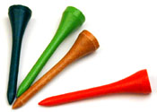

Constitution
1. Definitions and Interpretation
1.1 In this Constitution unless the contrary intention appears, “accounts” means profit and loss account, income and expenditure account and balance sheets, and includes statements, reports and notes attached to or intended to be read with any of these profit and loss accounts and balance sheets.
1.2 “Committee” means the Club Committee of the Club as defined in clause 4.1 of this Constitution.
1.3 “member” unless otherwise qualified, means a member of any category/class of membership, male or female, as set out in this Constitution.
1.4 “The Act” means the Associations Incorporation Act 1987.
1.5 “Voting members” means members who are eligible to vote at any Annual or Special Meeting
1.6 In this Constitution, if not inconsistent with the subject or the context, words denoting any gender shall include all genders, and words denoting the singular number shall include the plural and vice versa.
1.7 A reference to any statute in this Constitution includes a reference to that statute as amended, repealed, consolidated or substituted and includes orders, ordinances, regulations, rules and by-laws made under or pursuant to that statute.
1.8 Any By-Laws made by The Committee or any decision by The Committee on the construction or interpretation of the Constitution or of any By-law made pursuant thereto shall be subject to confirmation or revision by the members of the Club in General Meeting or by a Court, having appropriate jurisdiction in Western Australia. Any such decisions shall be binding on all members of the Club.
Amendments to the Constitution
1.8 This Constitution may not be amended, suspended or substituted except by a Special Resolution passed by a majority of not less than three fourths (75%) of the total votes cast by members present and entitled to vote at a General Meeting held for that purpose.
1.9 The notice of motion of a Special Resolution proposing an amendment to or suspension or substitution of the Constitution shall be lodged with the Captain and posted on the Club Notice Board thirty (30) days before the date of the General Meeting.
1.10 Within one month after making any alteration to the Constitution, The Committee shall provide the Commissioner for Corporate Affairs with the notice of Special Resolution setting out particulars of the alteration and a certification on the form required by the Act.

2. Name, Location and Purpose
2.1 The name of the Club is The SCUDS SOCIAL GOLF CLUB Inc. hereinafter referred to as “The Club”.
The Club shall be an association incorporated under the Associations Incorporation Act 1987.
Club Colours and Emblem
2.3 The official Club colours shall be white conforming to (colour FFFFFF) with a black Trim (colour 000000).
2.7 To conduct a golf and social club and to provide for the use of members and visitors.
The Club emblem (logo)
2.4 The Club emblem (logo)
2.5 Shall be the figure of a golf green with a red flag and a large tree left of center aligned with small
row of bushes. A golden sun will be on the right of the green and the words SCUDS in gold
(colour f6c20f), or Black (colour 000000). Font: Arial Black 48pt Regular uppercase (sample shown).
A copy of the logo design sample will be held by the Club Secretary.
2.6 The Common Seal shall be held by the Club Secretary
Objectives The objectives of the Club are:
2.7 To conduct a golf and social club and to provide for the use of members and visitors.
2.8 To promote, encourage and foster the playing of the game of golf and to provide all things incidental to the attainment of these objects. To apply the property and income of the club solely towards the promotion or objects of the club and no part of the property or income may be paid or otherwise distributed, directly or indirectly, to members 2.8 To promote, encourage and foster the playing of the game of golf and to provide all things incidental to the attainment of these objects. To apply the property and income of the club solely towards the promotion or objects of the club and no part of the property or income may be paid or otherwise distributed, directly or indirectly, to members of the club, except in good faith for the promotion of those objects or purposes.
2.9 To promote, encourage and foster a social outlet for club members, throughout the season the Club holds various social events. Membership of the Social Club is non-compulsory although expected.
Social Club
2.10 The Club also holds various fund raising activities such as raffles, etc, with all funds raised going towards social functions and an end of season dinner and trophy presentation night.
2.11 The Fee for social club membership shall be set by the Captain or nominated Social Club Manager.
subscription, affiliation fees and any other monies due, the person shall be enrolled as a member of the Club on the register from that date.
Other Clubs
2.12 Membership of the Birdie Club is non-compulsory and is drawn each week at appropriate competitions. Other clubs may be formed at the discression of the committee.
Section Three: Rules, Discipline, Expulsion and Resignations Liability of Members

3 Membership: Categories, Classes and limits Three categories of membership are available
3.1 Full Member Note: The Committee may at any time decide that the number of members in any category shall be limited. Any such limits decided by The Committee shall be prescribed in the By-laws. The payment of the prescribed annual fee entitles the member to compete in all Club competitions and shall be entitled to exercise all the rights and privileges of the Club including voting rights and eligibility to stand for positions on The Committee.
Full Members must be registered as a member of the GolfWA Association and hold a recognised handicap.
Note: Membership of GolfWA includes a Golf Link Handicap Card. Only full and part time members will hold recognized handicaps and be eligible to vote at meetings. Only a member who has the right to vote under the existing rules may participate in a vote on a proposed special resolution.
3.2 Member Part Time - The payment of the prescribed monthly fee entitles the member to compete in any Club competition in that month.
3.3 Visitor - Any person may play for any of the novelty prizes by payment of the novelty fee. Visitors will not be eligible to win the club competition for that day, however they may be eligible for novelty prizes upon application to the Captain and after the appropriate fee has been paid.
Election of Members Nominations
3.4 Every candidate for membership, except Life, or Honorary Members, shall be given a copy of this Constitution and By-laws and shall be proposed by one and seconded by another member of the Club, both of whom shall be members of the Club.
3.5 All applications for membership shall be considered by The Committee and accepted or rejected by a majority vote. Any candidate whose application for membership is rejected shall not again be eligible for nomination unless The Committee otherwise determines.

Annual General or Special General Meeting.
3.6 The Annual General Meeting (AGM) shall be held on a suitable date in December at a venue nominated to all members at least 14 days prior to the meeting, and members irrespective of membership class or voting rights shall receive written notification of such meeting, 51% of members shall constitute a quorum.
The main business of the AGM shall be the election of office bearers and the approval of the fee structure. Elected members of The Committee shall assume their appointments at the conclusion of the Annual General Meeting at which their election is declared.
3.7 A general committee meeting shall be held each quarter during the club year. Usually first week of March, June and September. A minimum of three committee members shall make a quorum.
3.8 A special general meeting can be called by 20% of members, either the officers or members to discuss a specific SUBJECT PROVIDING THE INTENTION TO CALL a meeting and the subject to be discussed is notified to all members at least fourteen days prior to the meeting.. The special resolution is passed if it is agreed to be at least 75% of the members who vote at the meeting (not 75% of the total Members must have a Golf Link Card for competition purposes a Membership card can be obtained through Scuds membership and affiliated membership of the GolfWA Association and will come into effect after three (3) stroke rounds played to determine the starting handicap
Enrollment of New Members
3.9 On election of a member the Captain shall at once give the member notice thereof and subject to the payment of any nomination fee, subscription, affiliation fees and any other monies due, the person shall be enrolled as a member of the Club on the register from that date.
Rules, Discipline, Expulsion and Resignations
3.10 Any member shall be liable to censure or suspension by The Disciplinary Committee (Captain, Treasurer & Handicaper) if that member refuses or neglects to comply with this Constitution or any By-law of the Club or any order or direction by The Committee or of any General Meeting or is guilty of any act or conduct detrimental to the interest of the Club or other members.
Committee Meeting Hearings
3.11 The Committee shall deliver in person or send a notice to the member’s recorded address advising the member of any charges, the time, place and date of the Board meeting at which the question shall be determined and particulars of the member’s alleged offence or conduct. At least seven (7) days notice of such meeting shall be given and if the member fails to attend, The Committee shall proceed and decide the case as if the member was present.
Censure/Suspension
3.12 If after hearing the evidence The Committee considers that the charge is sustained, it may censure the member or suspend the member for a specified period not exceeding twelve (12) months during which the member is denied access to any or all privileges, facilities and rights of the Club.
Expulsion
3.13 If, in the opinion of The Committee, a member’s action is so detrimental to the interests of the Club that expulsion is warranted, The Committee, in its discretion and after due consideration of all evidence, may expel the member from the Club.
Notwithstanding any such expulsion, the member so expelled shall be liable to the Club for all monies due by the member at the time of expulsion.
3.14 The expelled member (provided that member is financial), shall have the right to appeal by calling a Special General Meeting, in accordance with Rules, to have the matter determined. Any such determination shall be final and binding.
3.15 No person shall be entitled to take action or proceedings against the Club or in respect of any such censure, suspension or expulsion and must conform to the decision of The Committee or Special General Meeting. An expelled member forfeits all rights to be nominated for membership at any future date.
Resignation of Members
3.16 Any member wishing to resign from the Club shall give notice of such intention in writing to the Captain on or before the first day of February next occurring.
Otherwise the member shall be liable to pay the full applicable subscription for the current financial year or such an amount, not exceeding the full subscription, as may be decided by The Committee.
3.17 If a members fees lapse by three (3) months the membership will lapse and the member will need to re apply to the club for membership. The member shall be liable to pay the full applicable subscription for the current financial year or such an amount, not exceeding the full subscription, as may be decided by The Committee.
3.18 If a member has be absent from the club for a period of more than twelve (12) months, if the member’s Golf Link card is current that handicap will be used, if the Golf Link card is no longer valid, then the member must submit three new stroke round cards as approved by the committee before any application to re join is accepted. The member shall be liable to pay the full applicable subscription for the current financial year or such an amount, not exceeding the full subscription, as may be decided by The Committee.

4 The Committee of Management
4.1 The Committee of Management shall be responsible for the management of the Club and shall consist of Captain, Treasurer, Secretary, Club handicapper and a Media & Communications Officer. The positions of Club Captain, Treasurer, Secretary, Club handicapper and Media & Communications Officer can only be filled by a Full or Life Member. All positions shall be elected for a term of one year.
All committee members shall retire at the end of the year, however retiring members may nominate for re-election.
Duties

Club Captain/ Match Organiser - To organise the draw each playing day and determine the prize winners.

Secretary - To handle all correspondence and maintain the minutes of all Club Meetings.

Treasurer - To manage all club finances and maintain a record of receipts and expenditures.

Handicapper - To carry out the duties of handicapper in accordance with the Golf Link rules, arrange all fixtures including away fixtures and maintains all handicap records.

Media & Communications Officer - To manage the club’s web page and electronic communication and inform members of other club competitions or events as advised, and undertakes such communication duties as directed by the committee.

Social Club Manager Shall arrange club functions for social events as requested or suggested by members.

Match Committee - Shall be convened by the Committee usually the Captain and Handicapper along with another so nominated by the committee, and may (include all other officers). To adjudicate any matters on the rules of golf arising from any competition, arrange and conduct fixtures and assist in the general running of the Club.

SCUDS Handbook 2023 Page 7



SCUDS Handbook 2023 Page 6

SCUDS Handbook 2020 Page 6

